Создание программного raid-массива.

fdiks /dev/sda1 и fdiks /dev/sdb1
присвоить тип t номер типа fd

Например создание зеркала raid 1 из двух дисков
mdadm --create --verbose /dev/md0 --level=1 --raid-devices=2 /dev/sda1 /dev/sdb1
Или тоже самое для создания raid 5 из трёх дисков
mdadm --create --verbose /dev/md0 --level=5 --raid-devices=3 /dev/sda1 /dev/sdb1 /dev/sdc1

Просмотр статистики
cat /proc/mdstat

mkfs.ext4 -L label1 /dev/md0

mount /dev/md0 /mnt/md0

Создание файла конфигурации raid-массива. Полезно чтобы в случае чего ядро линукса могло автоматически пересобрать raid и самому для информации о том что было-то.
mdadm --detail --scan --verbose > /etc/mdadm.conf

Отключение raid-массива
mdadm -S /dev/md0
потом
rm -rf /dev/md0
и если не нужно, то удалить файл /etc/mdadm.conf

В /etc/fstab строчка монтирования выглядит так
/dev/md0 /mnt/raid1 auto defaults 0 0

http://www.howtoforge.com/how-to-create-a-raid1-setup-on-an-existing-centos-redhat-6.0-system

How To Create A RAID1 Setup On An Existing CentOS/RedHat 6.0 System

By: Maurice Hilarius - Hard Data Ltd. - October 12, 2011
This tutorial is for turning a single disk CentOS 6 system into a two disk RAID1 system. The GRUB bootloader will be configured in such a way that the system will still be able to boot if one of the hard drives fails (no matter which one).
NOTE: Everything has to be done as root:
su -
enter root password
In this example the initial layout for the hard disks was:
Disk with installed OS. "Original"
Device Mountpoint Size
--------------------------------------------------------------------------------
/dev/sdb ~1002GB
/dev/sdb1 /boot 256MB
/dev/sdb2 / 24GB
/dev/sdb3 swap 4GB
/dev/sdb5 /var 4GB
/dev/sdb6 /home ~900GB
And we will be adding the other hard disk: /dev/sda (~1002GB). "Target disk".
1. Back everything up! You might want to get your data back after you crashed the conversion. Trust me on this!
2. Verify Backup! See above.
3. Create partitions on /dev/sda identical to the partitions on /dev/sdb:
sfdisk -d /dev/sdb | sfdisk /dev/sda
4. We load a few kernel modules (to avoid a reboot):
modprobe linear
modprobe raid0
modprobe raid1
5. Now run:
cat /proc/mdstat
The output should look as follows:
root@server:~# cat /proc/mdstat
Personalities : [linear] [multipath] [raid0] [raid1]
unused devices: <none>
Here we see now that the RAID kernel modules are working, but there are no RAID sets yet.
6. Run the following commands:
mdadm --create /dev/md0 --level=1 --raid-disks=2 /dev/sda1 missing
mdadm --create /dev/md1 --level=1 --raid-disks=2 /dev/sda2 missing
mdadm --create /dev/md2 --level=1 --raid-disks=2 /dev/sda5 missing
mdadm --create /dev/md3 --level=1 --raid-disks=2 /dev/sda6 missing
This generates the raid devices 0 to 3 in a degenerated state because the second drive is missing.
7. If you want to use Grub 0.97 (default in CentOS 5 or 6)) on RAID 1, you need to specify an older version of metadata than the default. Add the option "--metadata=0.90" to the above command. Otherwise Grub will respond with "Filesystem type unknown, partition type 0xfd" and refuse to install. This is supposedly not necessary with Grub 2.
Like this:
mdadm --create /dev/md0 --metadata=0.90 --level=1 --raid-devices=2 /dev/sda1 missing
8. Check the output of
cat /proc/mdstat
#cat /proc/mdstat
Personalities : [raid1]
md1 : active raid1 sdb2[1]
473792 blocks [2/2] [U_]
md2 : active raid1 sdb5[1]
4980032 blocks [2/2] [U_]
md3 : active raid1 sdb6[1]
3349440 blocks [2/2] [U_]
md0 : active raid1 sdb1[1]
80192 blocks [2/2] [U_]
unused devices: <none>
9. Create a mdadm.conf from your current configuration:
mdadm --detail --scan > /etc/mdadm.conf
10. Display the contents of the file:
cat /etc/mdadm.conf
At the bottom of the file you should now see details about our (degraded) RAID arrays.
11. We use dracut to rebuild the initramfs with the new mdadm.conf:
mv /boot/initramfs-$(uname -r).img /boot/initramfs-$(uname -r).img.old
dracut --mdadmconf --force /boot/initramfs-$(uname -r).img $(uname -r)
12. Create the filesystems on these new software raid devices:
mkfs.ext2 /dev/md0 # For /boot ext2 is good
mkfs.ext4 /dev/md1 # For / ext4 is good
mkfs.ext4 /dev/md2 # For /home ext4 is good
mkfs.ext4 /dev/md3 # For /var ext4 is good
mkswap -c /dev/sda2 #We want swap partitions on both drives for performance
13. Copy the data from the existing (and still running) partitions to the newly created raid partitions:
mkdir /mnt/raid
mount /dev/md0 /mnt/raid
cd /boot; find . -depth | cpio -pmd /mnt/raid
(If SELinux is in use also do this:
touch /mnt/raid/.autorelabel
)
sync
umount /mnt/raid
mount /dev/md1 /mnt/raid
cd / ; find . -depth -xdev | grep -v '^\./tmp/' | cpio -pmd /mnt/raid
sync
umount /mnt/raid
NOTES: You really do not want to copy files in /tmp and /var/tmp.
This command will create empty mount points like 'proc' or 'dev' and will not forget things like /.autofsck.
mount /dev/md2 /mnt/raid
cd /var; find . -depth | cpio -pmd /mnt/raid sync umount /mnt/raid
mount /dev/md3 /mnt/raid
cd /home; find . -depth | cpio -pmd /mnt/raid
sync
umount /mnt/raid
At this point we have our raid system created and the existing data was mirrored manually onto the new devices.
To make sure that the system will boot from the raid devices we have to change some entries in /etc/fstab and /boot/grub/menu.lst.

How To Create A RAID1 Setup On An Existing CentOS/RedHat 6.0 System - Page 2
Want to support HowtoForge? Become a subscriber!
Submitted by mauriceh (Contact Author) (Forums) on Fri, 2011-10-21 15:14. ::

14. Open another console window and run:
blkid | grep /dev/md
Here you will see the UUID for each md type filesystem. It should look something like this:
/dev/md0: UUID="0b0fddf7-1160-4c70-8e76-5a5a5365e07d" TYPE="ext2"
/dev/md1: LABEL="/ROOT" UUID="36d389c4-fc0f-4de7-a80b-40cc6dece66f" TYPE="ext4"
/dev/md2: UUID="47fbbe32-c756-4ea6-8fd6-b34867be0c84" TYPE="ext4"
/dev/md3: LABEL="/VAR" UUID="f92cc249-c1af-456b-a291-ee1ea9ef8e22" TYPE="ext4"
Note the UUID for /dev/md0 and copy it and paste it in fstab as shown below.
mount /dev/md1 /mnt/raid
In /mnt/raid/etc/fstab change the line containing the mount point /boot to the UUID of the new /dev/md0 filesystem:
UUID=0b0fddf7-1160-4c70-8e76-5a5a5365e07d /boot ext2 defaults 1 1
Repeat for the UUID of the filesystem for the new / md device. Find it and copy it.
Now change the line containing the mount point for / to and paste in the UUID:
UUID=36d389c4-fc0f-4de7-a80b-40cc6dece66f / ext4 defaults 1 1
Later on we will use the following, but keep these two commented for the moment.
Keep the existing lines for mounting /var and /home intact.
The new line for mounting /var will be added:
/dev/sdb5 /var ext4 defaults 1 2
#UUID=47fbbe32-c756-4ea6-8fd6-b34867be0c84 /var ext4 defaults 1 2
The line for mounting /home will be added:
/dev/sdb6 /home ext4 defaults 1 2
#UUID=f92cc249-c1af-456b-a291-ee1ea9ef8e22 /home ext4 defaults 1 2
Next:
umount /mnt/raid
15. Mount /dev/md0 again to /mnt/raid.
In /mnt/raid/grub/menu.lst change the entry for the kernel to
kernel PATH-TO-KERNEL ro root=/dev/md1 SOME OPTIONS
Make sure that there is no longer an option to EXCLUDE md devices!
Just to be sure the system will boot from the raid array copy the file /mnt/raid/grub/menu.lst to /boot/grub/menu.lst and /mnt/raid/etc/fstab to /etc/fstab.
You could make copies of these files for safety, but that's the cowards way.
16. Reboot the machine.
Enter the system BIOS, and choose the new disk as the one that your system boots from. Save the BIOS setting and boot.
17. Assuming the reboot went smoothly, change the existing partitions of the old drive to be raid device partitions:
Check the partition tables to confirm which disk is the old and which is the new one:
fdisk -l
Examine the output and see which disk has partitions of type 83 Linux. That disk will be our old system disk.
By using fdisk, cfdisk or parted:
Change the partition type to 0xfd on that disks partitions sdb1, sdb2, sdb5 and sdb6. Note I am assuming here that this is still /dev/sdb.
Run
partprobe
Add the newly modified partitions to the RAIDs to make them complete. Note that once again I am assuming that the old disk still shows up as sdb.
mdadm /dev/md0 -a /dev/sdb1
mdadm /dev/md1 -a /dev/sdb2
mdadm /dev/md2 -a /dev/sdb5
mdadm /dev/md3 -a /dev/sdb6
To see what's going on, use (in a new console window as root):
watch -n 5 cat/proc/mdstat
The output should look similar to the one below and will be updated every 5 seconds:
Personalities : [raid1]
md1 : active raid1 sdb3[1] sda3[0]
473792 blocks [2/2] [UU]
[===>.................] recovery 25.0% (118448/473792) finish=2.4min speed=2412
md2 : active raid1 sdb5[1] sda5[0]
4980032 blocks [2/2] [UU]
resync=DELAYED
md3 : active raid1 sdb6[1] sda6[0]
3349440 blocks [2/2] [UU]
resync=DELAYED
md0 : active raid1 sdb1[1] sda1[0]
80192 blocks [2/2] [UU]
unused devices: <none>
As soon as all the md devices are done recovery, your system is in essence up and running.
Next we shall add some additional steps to gain on performance and redundancy.
First, the system should be able to boot even if the first hard disk fails. For this to happen, the following step has to be done:
18. Create a boot record on the second hard disk.
THESE INSTRUCTIONS ASSUME YOU ARE USING OLD STYLE GRUB. FOR GRUB2 SEE FUTURE INSTRUCTIONS!
To create a boot record on the second hard disk, start a grub shell:
# grub
grub>
Set the root device temporarily to the second disk:
grub> root (hd1,0)
Filesystem type is ext2fs, partition type is 0xfd
grub> setup (hd1)
Checking if "/boot/grub/stage1" exists ... no
Checking if "/grub/stage1" exists ... yes
Checking if "/grub/stage2" exists ... yes
Checking if "/grub/e2fs_stage1_5" exists ... yes
Running "embed /grub/e2fs_stage1_5 (hd1)" ... 16 sectors embedded.
succeeded
Running "install /grub/stage1 (hd1) (hd1)1+16 p (hd1,0)/grub/stage2 /grub/grub.conf"... succeeded
Done.
Repeat for the first disk:
grub> root (hd0,0)
Filesystem type is ext2fs, partition type is 0xfd
grub> setup (hd0)
Checking if "/boot/grub/stage1" exists ... no
Checking if "/grub/stage1" exists ... yes
Checking if "/grub/stage2" exists ... yes
Checking if "/grub/e2fs_stage1_5" exists ... yes
Running "embed /grub/e2fs_stage1_5 (hd1)" ... 16 sectors embedded.
succeeded
Running "install /grub/stage1 (hd0) (hd0)1+16 p (hd0,0)/grub/stage2 /grub/grub.conf"... succeeded
Done.
grub> quit
Reboot the system:
reboot
It should boot without problems.
If so, disconnect the first disk (sda) and try again. Does it boot?
If so, power off, reconnect sda, disconnect the second disk (sdb). Does it boot?

http://xmodulo.com/create-software-raid1-array-mdadm-linux.html

How to create a software RAID-1 array with mdadm on Linux
Last updated on September 16, 2014 Authored by Gabriel Cánepa 19 Comments
Redundant Array of Independent Disks (RAID) is a storage technology that combines multiple hard disks into a single logical unit to provide fault-tolerance and/or improve disk I/O performance. Depending on how data is stored in an array of disks (e.g., with striping, mirroring, parity, or any combination thereof), different RAID levels are defined (e.g., RAID-0, RAID-1, RAID-5, etc). RAID can be implemented either in software or with a hardware RAID card. On modern Linux, basic software RAID functionality is available by default.
In this post, we'll discuss the software setup of a RAID-1 array (also known as a "mirroring" array), where identical data is written to the two devices that form the array. While it is possible to implement RAID-1 with partitions on a single physical hard drive (as with other RAID levels), it won't be of much use if that single hard drive fails. In fact, that's why most RAID levels normally use multiple physical drives to provide redundancy. In the event of any single drive failure, the virtual RAID block device should continue functioning without issues, and allow us to replace the faulty drive without significant production downtime and, more importantly, with no data loss. However, it does not replace the need to save periodic system backups in external storage.
Since the actual storage capacity (size) of a RAID-1 array is the size of the smallest drive, normally (if not always) you will find two identical physical drives in RAID-1 setup.

Installing mdadm on Linux
The tool that we are going to use to create, assemble, manage, and monitor our software RAID-1 is called mdadm (short formultiple disks admin). On Linux distros such as Fedora, CentOS, RHEL or Arch Linux, mdadm is available by default. On Debian-based distros, mdadm can be installed with aptitude or apt-get.

Fedora, CentOS or RHEL
As mdadm comes pre-installed, all you have to do is to start RAID monitoring service, and configure it to auto-start upon boot:
# systemctl start mdmonitor
# systemctl enable mdmonitor
For CentOS/RHEL 6, use these commands instead:
# service mdmonitor start
# chkconfig mdmonitor on

Debian, Ubuntu or Linux Mint
On Debian and its derivatives, mdadm can be installed with aptitude or apt-get:
# aptitude install mdadm
On Ubuntu, you will be asked to configure postfix MTA for sending out email notifications (as part of RAID monitoring). You can skip it for now.
On Debian, the installation will start with the following explanatory message to help us decide whether or not we are going to install the root filesystem on a RAID array. What we need to enter on the next screen will depend on this decision. Read it carefully:
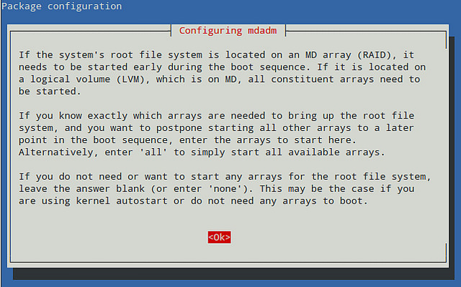
Since we will not use our RAID-1 for the root filesystem, we will leave the answer blank:
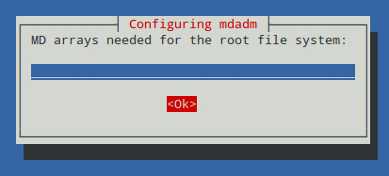
When asked whether we want to start (reassemble) our array automatically during each boot, choose "Yes". Note that we will need to add an entry to the /etc/fstab file later in order for the array to be properly mounted during the boot process as well.
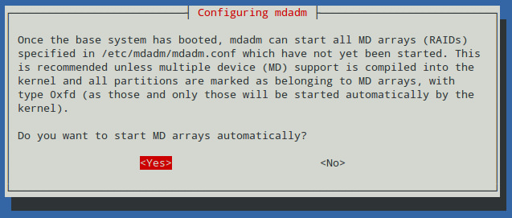

Partitioning Hard Drives
Now it's time to prepare the physical devices that will be used in our array. For this setup, I have plugged in two 8 GB USB drives that have been identified as /dev/sdb and /dev/sdc from dmesg output:
# dmesg | less
[ 60.014863] sd 3:0:0:0: [sdb] 15826944 512-byte logical blocks: (8.10 GB/7.54 GiB)
[ 75.066466] sd 4:0:0:0: [sdc] 15826944 512-byte logical blocks: (8.10 GB/7.54 GiB)
We will use fdisk to create a primary partition on each disk that will occupy its entire size. The following steps show how to perform this task on /dev/sdb, and assume that this drive hasn't been partitioned yet (otherwise, we can delete the existing partition(s) to start off with a clean disk):
# fdisk /dev/sdb
Press 'p' to print the current partition table:
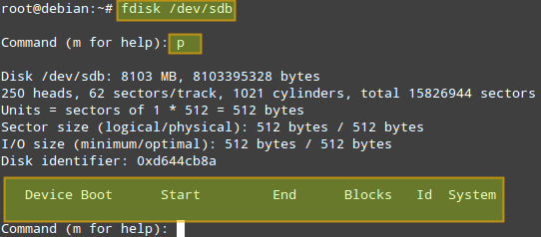
(if one or more partitions are found, they can be deleted with 'd' option. Then 'w' option is used to apply the changes).
Since no partitions are found, we will create a new primary partition ['n'] as a primary partition ['p'], assign the partition number = ['1'] to it, and then indicate its size. You can press Enter key to accept the proposed default values, or enter a value of your choosing, as shown in the image below.
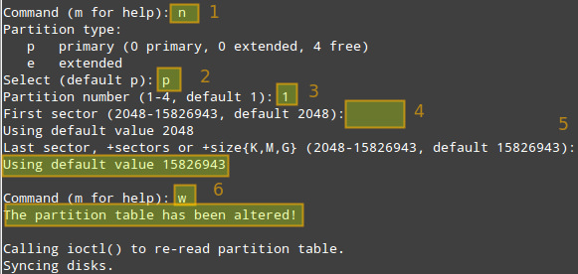
Now repeat the same process for /dev/sdc.
If we have two drives of different sizes, say 750 GB and 1 TB for example, we should create a primary partition of 750 GB on each of them, and use the remaining space on the bigger drive for another purpose, independent of the RAID array.

Create a RAID-1 Array
Once you are done with creating the primary partition on each drive, use the following command to create a RAID-1 array:
# mdadm -Cv /dev/md0 -l1 -n2 /dev/sdb1 /dev/sdc1
Where:
- -Cv: creates an array and produce verbose output.
- /dev/md0: is the name of the array.
- -l1 (l as in "level"): indicates that this will be a RAID-1 array.
- -n2: indicates that we will add two partitions to the array, namely /dev/sdb1 and /dev/sdc1.
The above command is equivalent to:
# mdadm --create --verbose /dev/md0 --level=1 --raid-devices=2 /dev/sdb1 /dev/sdc1
If alternatively you want to add a spare device in order to replace a faulty disk in the future, you can add '--spare-devices=1 /dev/sdd1' to the above command.
Answer "y" when prompted if you want to continue creating an array, then press Enter:
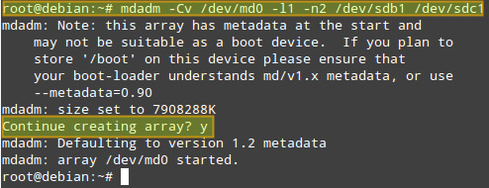
You can check the progress with the following command:
# cat /proc/mdstat
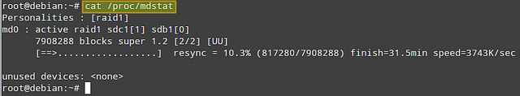
Another way to obtain more information about a RAID array (both while it's being assembled and after the process is finished) is:
# mdadm --query /dev/md0
# mdadm --detail /dev/md0 (or mdadm -D /dev/md0)
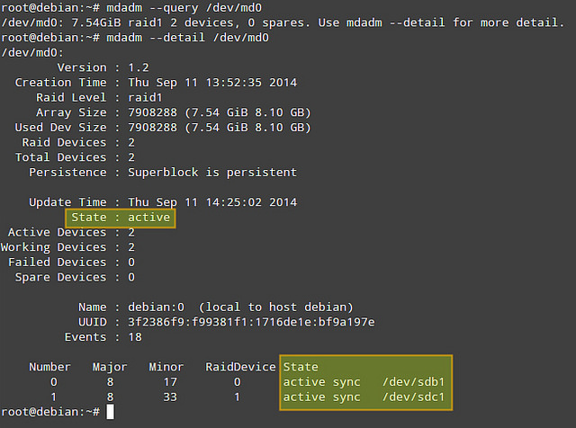
Of the information provided by 'mdadm -D', perhaps the most useful is that which shows the state of the array. The active state means that there is currently I/O activity happening. Other possible states are clean (all I/O activity has been completed),degraded (one of the devices is faulty or missing), resyncing (the system is recovering from an unclean shutdown such as a power outage), or recovering (a new drive has been added to the array, and data is being copied from the other drive onto it), to name the most common states.

Formatting and Mounting a RAID Array
The next step is formatting (with ext4 in this example) the array:
# mkfs.ext4 /dev/md0
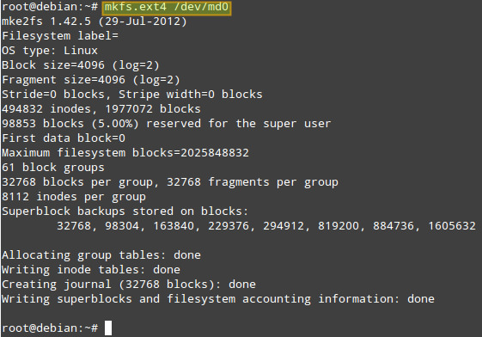
Now let's mount the array, and verify that it was mounted correctly:
# mount /dev/md0 /mnt
# mount
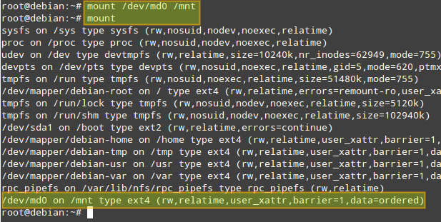

Monitor a RAID Array
The mdadm tool comes with RAID monitoring capability built in. When mdadm is set to run as a daemon (which is the case with our RAID setup), it periodically polls existing RAID arrays, and reports on any detected events via email notification or syslog logging. Optionally, it can also be configured to invoke contingency commands (e.g., retrying or removing a disk) upon detecting any critical errors.
By default, mdadm scans all existing partitions and MD arrays, and logs any detected event to /var/log/syslog. Alternatively, you can specify devices and RAID arrays to scan in mdadm.conf located in /etc/mdadm/mdadm.conf (Debian-based) or /etc/mdadm.conf (Red Hat-based), in the following format. If mdadm.conf does not exist, create one.
1  2  3  4  5  6  7  8 | DEVICE /dev/sd[bcde]1 /dev/sd[ab]1  ARRAY /dev/md0 devices=/dev/sdb1,/dev/sdc1  ARRAY /dev/md1 devices=/dev/sdd1,/dev/sde1  .....  # optional email address to notify events  MAILADDR your@email.com
After modifying mdadm configuration, restart mdadm daemon:
On Debian, Ubuntu or Linux Mint:
# service mdadm restart
On Fedora, CentOS/RHEL 7:
# systemctl restart mdmonitor
On CentOS/RHEL 6:
# service mdmonitor restart

Auto-mount a RAID Array
Now we will add an entry in the /etc/fstab to mount the array in /mnt automatically during boot (you can specify any other mount point):
# echo "/dev/md0 /mnt ext4 defaults 0 2" >> /etc/fstab
To verify that mount works okay, we now unmount the array, restart mdadm, and remount. We can see that /dev/md0 has been mounted as per the entry we just added to /etc/fstab:
# umount /mnt
# service mdadm restart (on Debian, Ubuntu or Linux Mint)
or systemctl restart mdmonitor (on Fedora, CentOS/RHEL7)
or service mdmonitor restart (on CentOS/RHEL6)
# mount -a
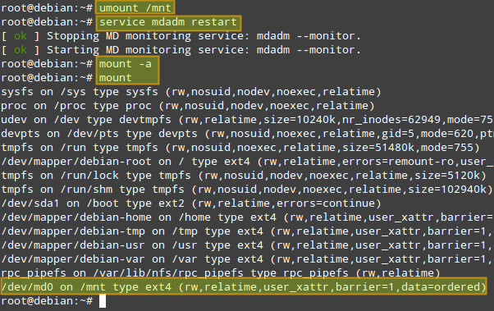
Now we are ready to access the RAID array via /mnt mount point. To test the array, we'll copy the /etc/passwd file (any other file will do) into /mnt:
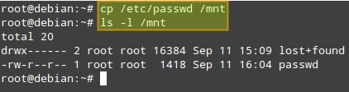
On Debian, we need to tell the mdadm daemon to automatically start the RAID array during boot by setting the AUTOSTART variable to true in the /etc/default/mdadm file:
1 | AUTOSTART=true

Simulating Drive Failures
We will simulate a faulty drive and remove it with the following commands. Note that in a real life scenario, it is not necessary to mark a device as faulty first, as it will already be in that state in case of a failure.
First, unmount the array:
# umount /mnt
Now, notice how the output of 'mdadm -D /dev/md0' indicates the changes after performing each command below.
# mdadm /dev/md0 --fail /dev/sdb1 #Marks /dev/sdb1 as faulty
# mdadm --remove /dev/md0 /dev/sdb1 #Removes /dev/sdb1 from the array
Afterwards, when you have a new drive for replacement, re-add the drive again:
# mdadm /dev/md0 --add /dev/sdb1
The data is then immediately started to be rebuilt onto /dev/sdb1:
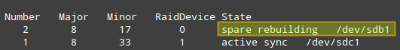
Note that the steps detailed above apply for systems with hot-swappable disks. If you do not have such technology, you will also have to stop a current array, and shutdown your system first in order to replace the part:
# mdadm --stop /dev/md0
# shutdown -h now
Then add the new drive and re-assemble the array:
# mdadm /dev/md0 --add /dev/sdb1
# mdadm --assemble /dev/md0 /dev/sdb1 /dev/sdc1
Hope this helps.

Subscribe to Xmodulo
Do you want to receive Linux FAQs, detailed tutorials and tips published at Xmodulo? Enter your email address below, and we will deliver our Linux posts straight to your email box, for free. Delivery powered by Google Feedburner.

https://access.redhat.com/documentation/en-US/Red_Hat_Enterprise_Linux/5/html/Deployment_Guide/s2-raid-manage-removing.html

6.3.5. Removing a RAID Device
To remove an existing RAID device, first deactivate it by running the following command as root:
mdadm --stop raid_device
Once deactivated, remove the RAID device itself:
mdadm --remove raid_device
Finally, zero superblocks on all devices that were associated with the particular array:
mdadm --zero-superblock component_device…
⁠
Example 6.5. Removing a RAID device
Assume the system has an active RAID device, /dev/md3, with the following layout (that is, the RAID device created in Example 6.4, “Extending a RAID device”):
~]# mdadm --detail /dev/md3 | tail -n 4
Number Major Minor RaidDevice State
0 8 1 0 active sync /dev/sda1
1 8 17 1 active sync /dev/sdb1
2 8 33 2 active sync /dev/sdc1
In order to remove this device, first stop it by typing the following at a shell prompt:
~]# mdadm --stop /dev/md3
mdadm: stopped /dev/md3
Once stopped, you can remove the /dev/md3 device by running the following command:
~]# mdadm --remove /dev/md3
Finally, to remove the superblocks from all associated devices, type:
~]# mdadm --zero-superblock /dev/sda1 /dev/sdb1 /dev/sdc1

